**DATA MINING**

**FP Growth algorithm**

**Exercise number: Date: 30.07.2024**

Aim: To implement FP growth algorithm

Q1. FP growth algorithm for a given dataset.

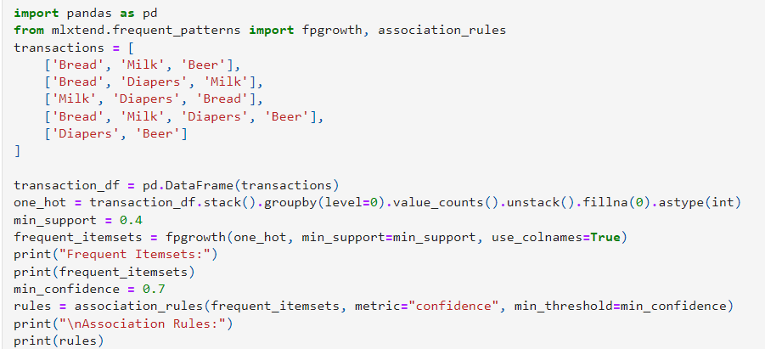

Output:

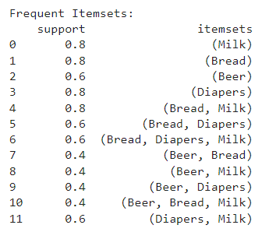 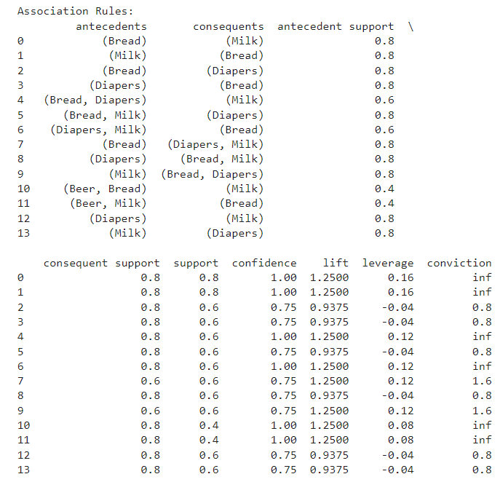

Q2. FP growth algorithm for a given dataset(CSV file)

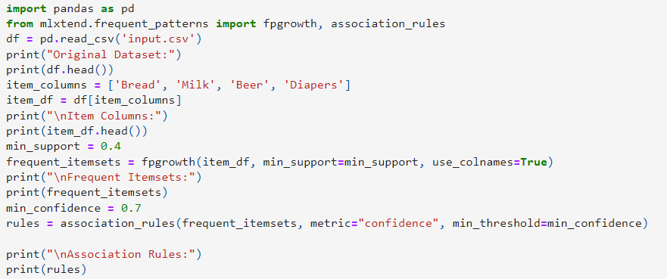

Output:

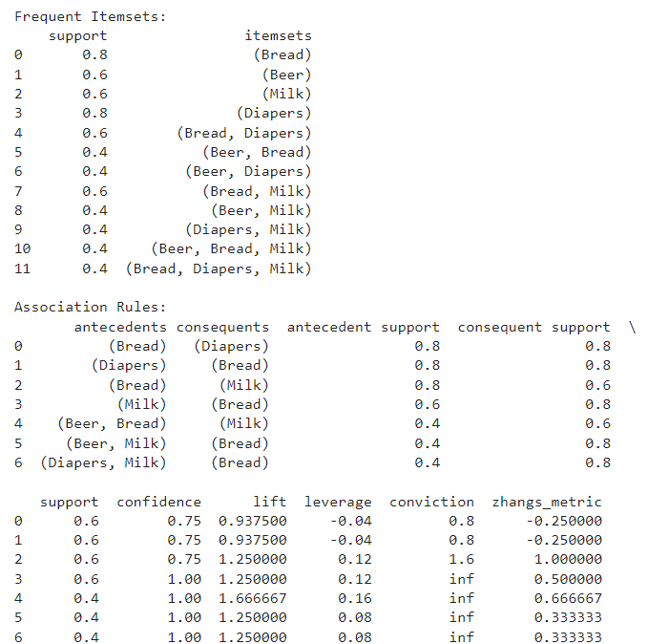

Q3. FP growth algorithm for a given dataset without built-in functions.

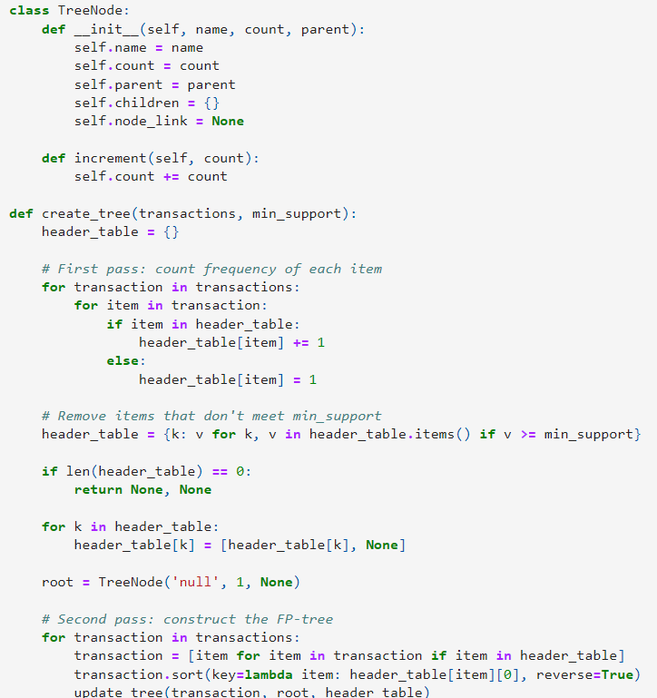

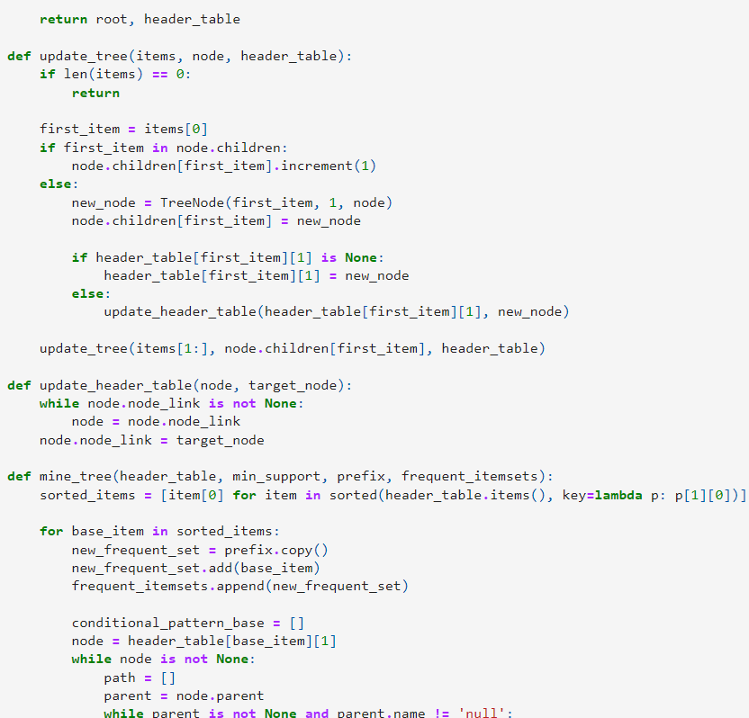

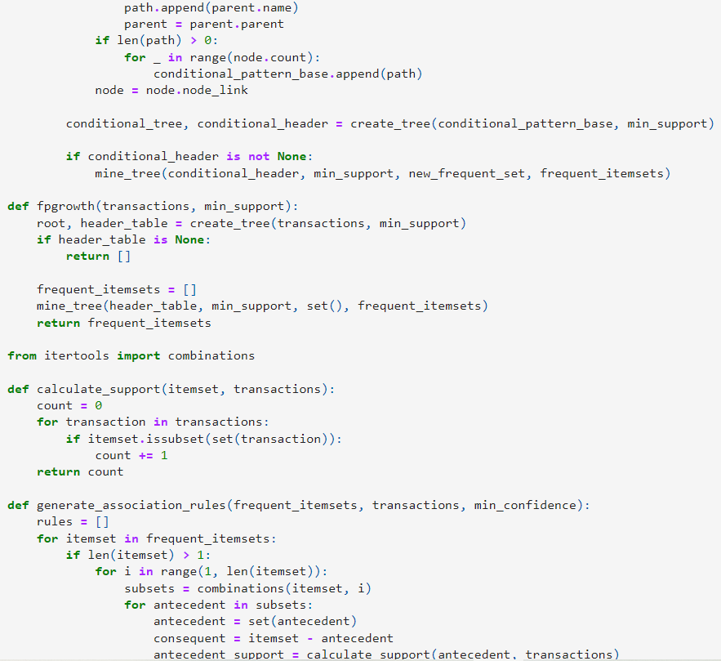 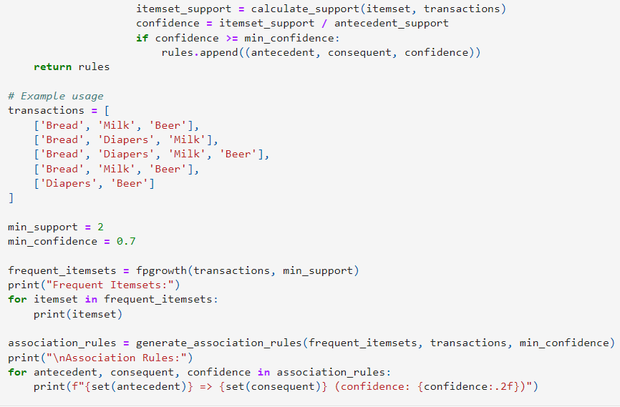

Output:

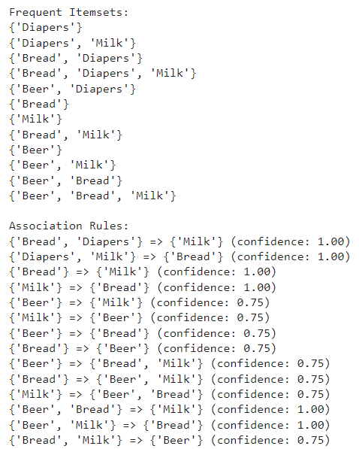

Result:

All code executed successfully.